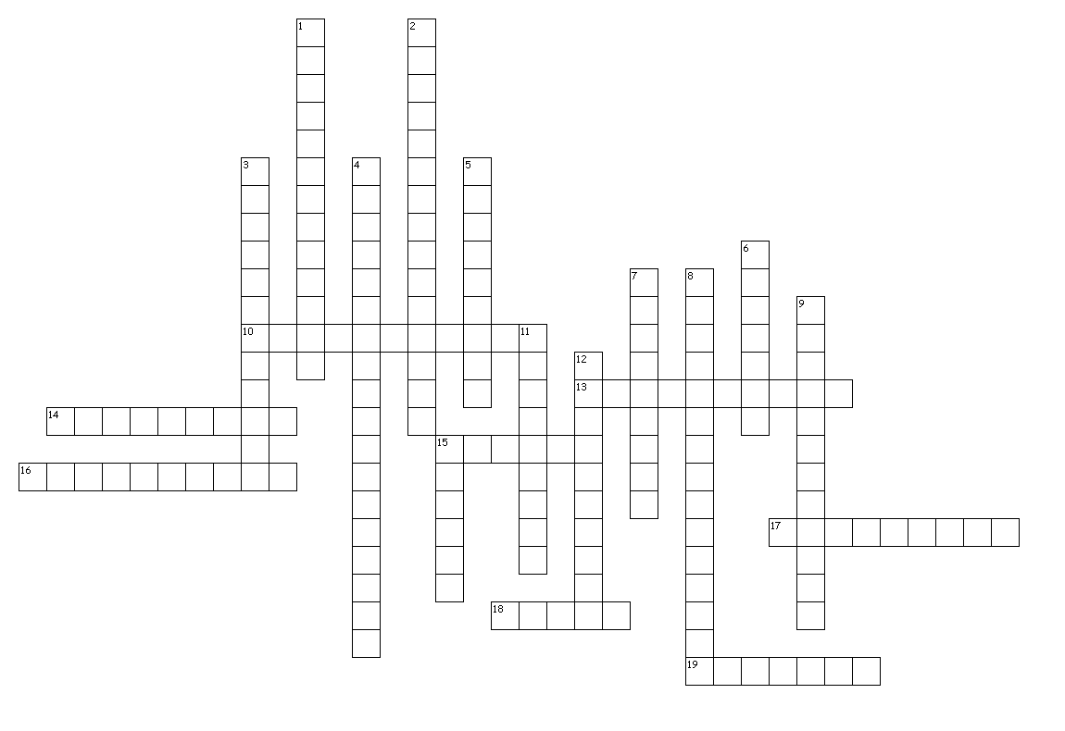**Nutrition Vocabulary**

Across

10. transfer of energy to other body parts

13. prevents food from entering windpipe

14. a solution that is high in calcium or magnesium ions

15. starts digestive process in mouth by secreting food and breaking it down

16. required to mix a polar and nonpolar substance by sharing properties of both

17. the process the body uses to break food into nutrients

18. thin soupy mixture of food in stomach

19. inorganic element that is essential to the body's functioning

Down

1. food rich in nutrients and low in calories

2. runs from mouth, through the intestines, to the anus

3. gives sweet potatoes their color and the body a source of vitamin A

4. the six nutrients needed to live (carbs, proteins, fats, water, vitamins, minerals)

5. chemical reaction when oxygen meets various elements

6. disease imparing body development in children (caused by a lack of vitamin D)

7. the study of how our bodies use food to make energy

8. energy used at rest to maintain life-supporting body functions

9. muscle contractions in stomach that carry food to the next location

11. substances found in food that fuel cellular energy

12. all the chemical reactions that occur in cells to supply energy to the body

15. lack of vitamin C